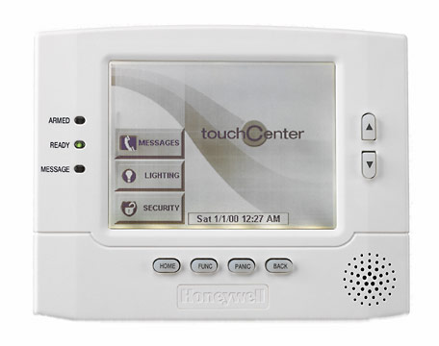
6270 – BLACK & WHITE GRAPHIC CONSOLE

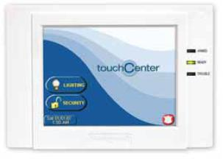

6271CV – COLOR GRAPHIC CONSOLE

